The Challenge

In this activity, you will assume the role of a pen tester hired by a bank to test the security of the bank‚Äôs authentication scheme, sensitive financial data, and website interface.

#### Lab Environment

We'll use the **Web Vulns** lab environment. To access it:

- Log in to the Azure Classroom Labs dashboard.

- Find the card with the title **Web Vulns** or **Web Vulnerability and Hardening**.

- Click the monitor icon in the bottom-right.

- Select **Connect with RDP**.

- Use Credentials (azadmin:p4ssw0rd*)

- The lab should already be started, so you should be able to connect immediately.

- Refer to the [lab setup instructions](https://cyberxsecurity.gitlab.io/documentation/using-classroom-labs/post/2019-01-09-first-access/) for details on setting up the RDP connection.

Once the lab environment is running, open the HyperV manager and make sure that the OWASPBWA and Kali box is running.

- Then, login to the Kali VM and navigate to the IP address of the OWASPBWA machine.

- Click the option for 'WebGoat' and start the WebGoat app.

- Use the credentials: `guest`:`guest`

On the bottom of the left side of the screen, click on `Challenge` and then choose `The Challenge`.

**Note:** A common issue with this lab is the Challange activity failing to start successfully. Hit the `Restart the Lesson` button in the top right if you get an error starting the activity.

### The Challenge Instructions

#### Challenge #1

Your first mission is to break the authentication scheme. There are a number of ways to accomplish this task.

- **Hint #1**: Sometimes, form fields are shy!

- **Hint #2**: Find the hidden JavaScript.

- **Hint #3**: You can appened `source?source=true` to the URL to read the source code.

After completing the first challenge, you will be provided with an option to continue to the next challenge.

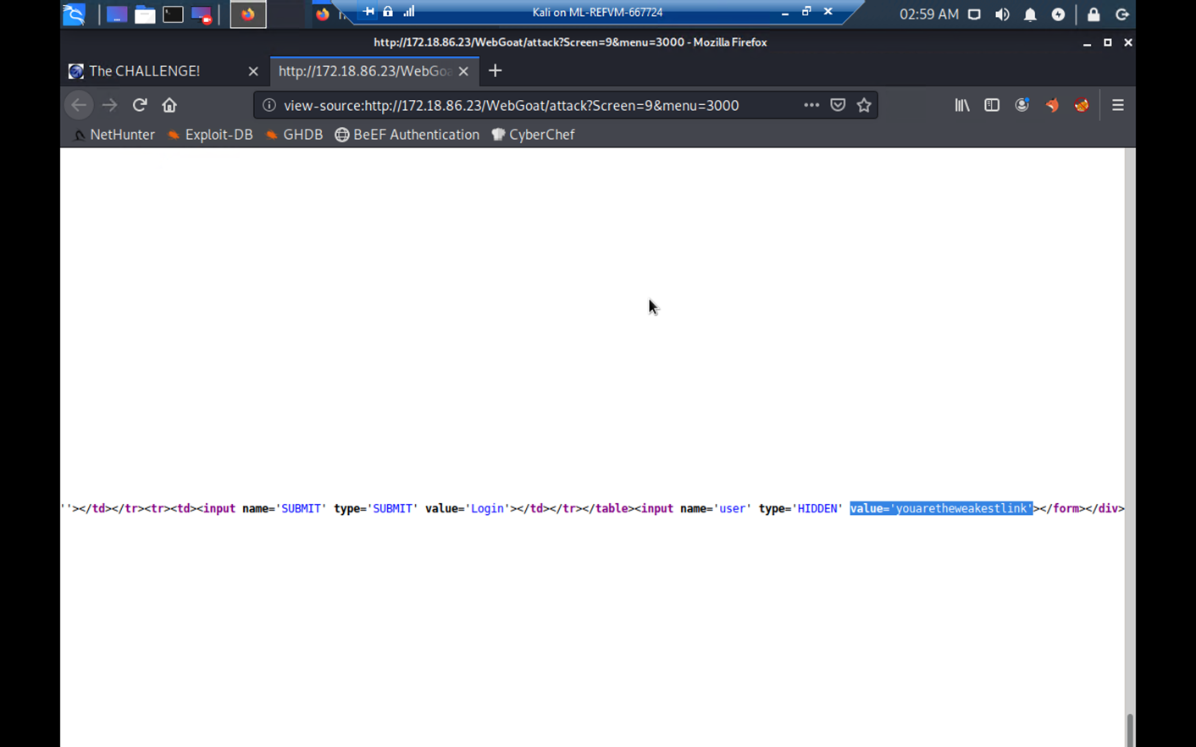

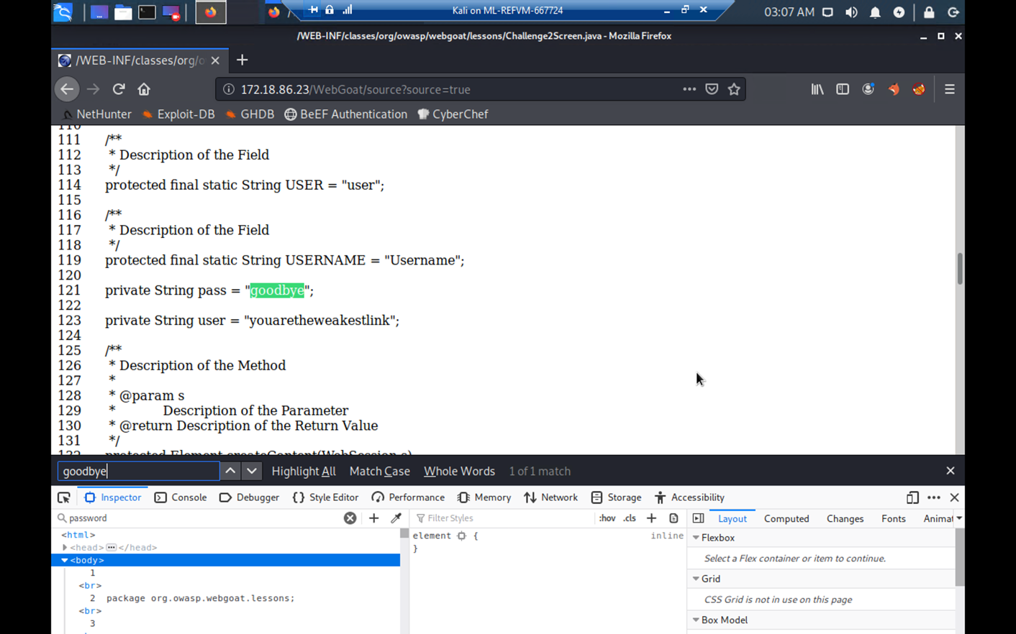

#### Challenge #2

Next, steal all of the credit card numbers from the database.

**Hint #1**: Sometimes cookies wear different clothes to change their appearances.

- **Hint #2**: Break your way into the conversation and inject your own ideas.

After completing the second challenge, you will be provided with an option to continue to the next challenge.

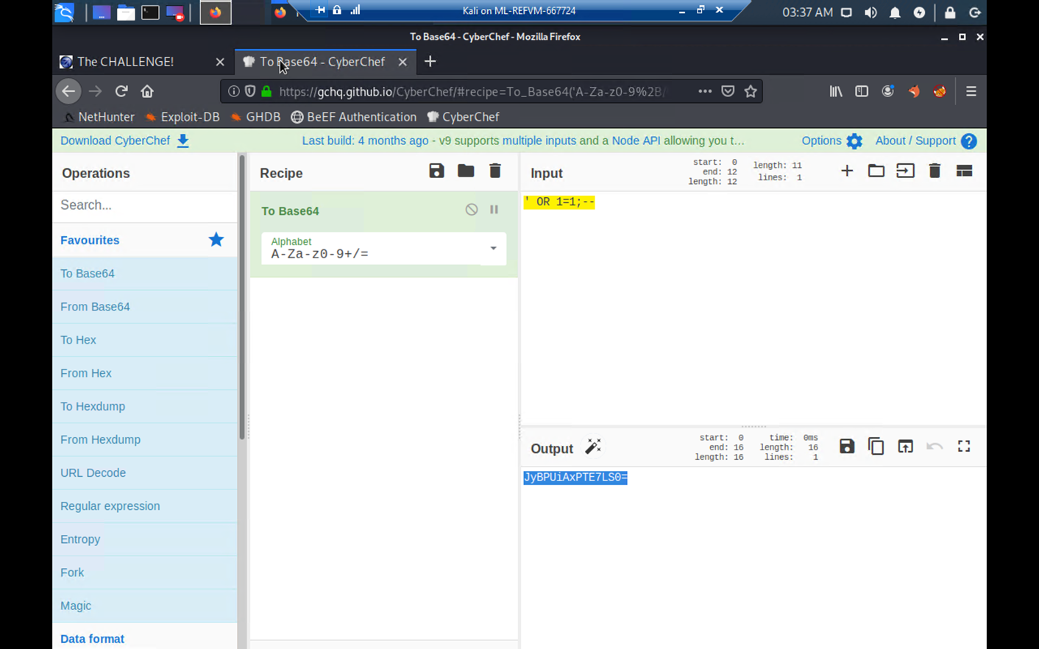

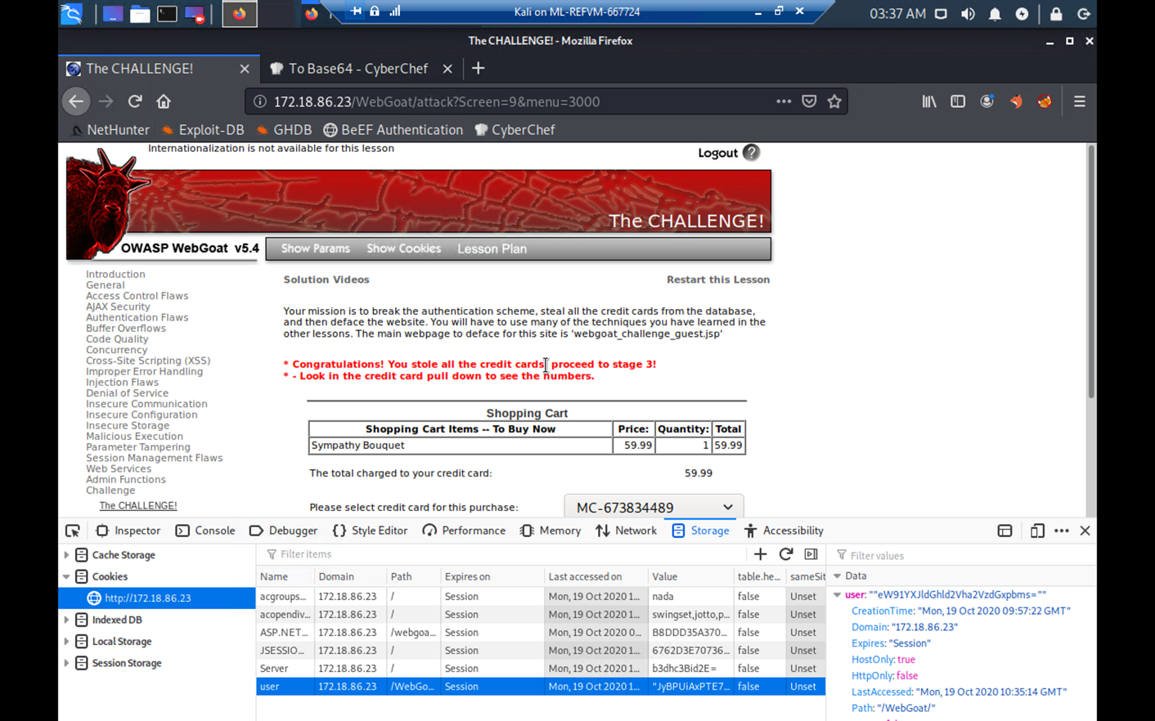

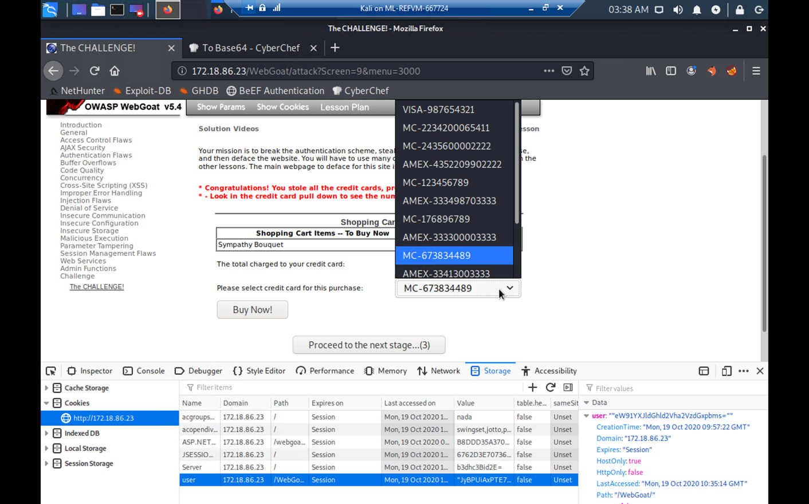

#### Challenge #3

Your final act is to deface the website using command injection. Follow the walkthrough below to help you get started.

- After completing the second challenge, you will be provided with an option to continue to the next challenge.

![cracked credit cards](Images/credit_cards-cracked.png)

- There should be two webpages at the bottom of the window. The one on top is the original, and the one on the bottom is the defaced webpage.

![original webpage](Images/original_defaced.png)

- Start Foxy Proxy (WebScarab) to send all GET/POST requests from Firefox to the WebScarab proxy intercept.

![Foxy Proxy](Images/foxy_proxy_scab.png)

- Click **TCP** and then the **View Network** button and send the request to WebScarab.

![View Network](Images/view_network_tcp.png)

- The WebScarab window will open.

- In the **URL Encoded** tab, find the **File** and **Value** form fields.

- This is where you will perform your command injection.

![File Field](Images/webscarab_file_value_field.png)

- Next, perform a test and see if this shell is vulnerable to command injection.

- Type the following command into the Value field: `tcp && whoami && pwd`.

- **Note:** Windows users can type `tcp && dir`. `dir` will return the directory as proof of vulnerability.

- Click **Accept Changes**.

![whoami](Images/whoami_pwd_image.png)

- On the next window, click **Accept Changes** twice.

![accept](Images/webscarab_2nd_window.png)

- Scroll to the bottom of the **Current Network Status** window and observe the results for both of the `whoami` and `pwd` commands.

![whoami & pwd](Images/whoami_pwd.png)

- The results show that we are the root user and our current working directory is `/var/lib/tomcat6`.

- This verifies the vulnerability, so proceed to the next step.

- Next, we'll locate the `webgoat_challenge_guest.jsp` file.

- Type the following command: `tcp && cd / && find . -iname webgoat_challenge_guest.jsp`.

- **Note**: Windows users will need to type: `tcp && dir /s 'webgoat_challenge_guest.jsp'`

![find command](Images/webscarab_find_command.png)

- The absolute path is: /`.

![absolute path](Images/webscarab_abolute_path.png)

- Remember, our present working directory is `/var/lib/tomcat6`. Therefore, the relative path is `webapps/WebGoat/webgoat_challenge_guest.jsp`.

**Now it's your turn**

- Now that we know where the webpage is, your task will be to deface the website. Keep in mind the following:

* Use **WebScarab** to perform command injection.

* When performing command injection, you will need to select a field that WebScarab can return commands to. These fields are typically located in a drop down.

* You will also need to locate and edit the the webpage's source code: `webgoat_challenge_guest.jsp`

* Your final command will:

* Change to the location of the `webgoat_challenge_guest.jsp` file.

* **and** echo `You've been hacked.` to the `webgoat_challenge_guest.jsp` file.

